1. Component Name- Geofence Map
2. Short Description - Component is used for Create Geofence in Google map
3. Long Description - Geofence is defined by a latitude, a longitude and a radius. It's a circular area at a specific location that an app can use to trigger particular behaviors when a device enters, exits or stays for a certain amount of time within geofence boundaries.
4. Images of the component to be displayed in the detail view-
5. Type of Component I.e. Android java
6. Contributor Name (if possible)-Ganapathy P.
7. Thumbnail image for the component to be displayed in the list- N/A
8. Following files if available
   1. Source Code-Attached in Zip
   2. Usage Document-yes
   3. Any demo created-yes

Reference Link:

<https://developers.google.com/maps/documentation/android-sdk/start>

<https://developer.android.com/training/location/geofencing>

<https://developers.google.com/android/guides/setup>

Note:

This feature will be supported from android [JELLY BEAN](https://developer.android.com/reference/android/os/Build.VERSION_CODES#JELLY_BEAN_MR1)

We can use this component for various tracking management purpose I.e. Monitoring assets, Location tracking and sale force management.

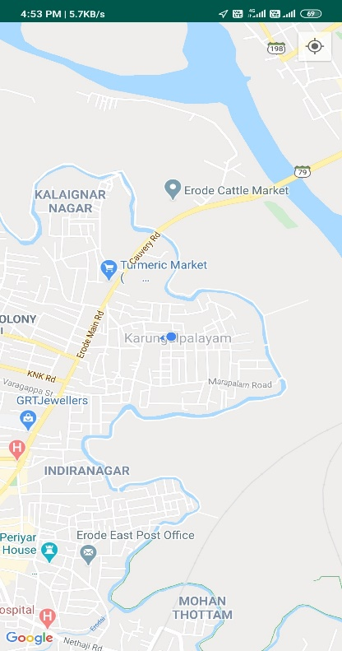

Landing page Geofence created and entered Geofence Entered Notification

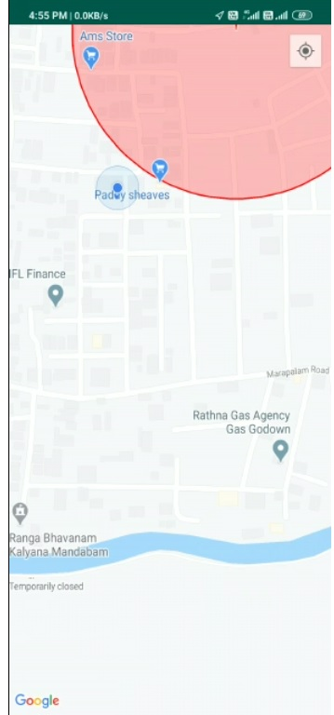

Geofence Exit Notification Device Exited from Geofence